Road Decommissioning Monitoring Protocol
Six Rivers National Forest
DRAFT March 22, 2002

Background

In the past decade, Six Rivers National Forest has decommissioned approximately 176 miles of forest roads. The focus of decommissioning efforts has been to improve water quality through the reduction of sediment introduced to streams, although opportunities to remove roads from the need for maintenance have also occurred. The primary treatment has been the removal of stream crossings and associated fill, and installation of water bars or other drainage structures to make the road free-draining. In some cases, the roadbed was ripped or sub-soiled, or trees were planted to speed up revegetation. Roads were not obliterated (i.e., fully recontoured) but were put in a free-draining and maintenance free condition.

Since the restoration program began, monitoring has been limited to end of project reviews and 1 or 2 post-winter reviews at best. Monitoring has been qualitative assessments as to the success of treatments. Because we will continue to decommission roads in the future, at this point we would like to examine past road decommissioning projects and see how they are doing.

Specific goals of the project are to:

• quantify effectiveness of past projects in reducing/eliminating sediment inputs;
• identify successful/unsuccessful treatment techniques (i.e., ripping, leaving road prism intact, leaving ditches that drain springs intact, etc.);
• develop a means to predict when future projects may need special treatments;
• identify any limiting factors contributing to less than fully successful road decommissioning.

Methods

The basic monitoring strategy will be to measure and document the amount and type of erosion associated with decommissioned roads and attempt to relate that with various independent variables. Independent variables would be: bedrock geology, soil type, hillslope position, hillslope gradient, stream power, size of excavation, time since implementation, and contract method. Most of this analysis will be an office/GIS exercise, although collection of good erosion data in the field is crucial to the success of the analysis.

Field Methods

Field crews will measure the amount of material excavated from stream crossings as well as the volume of any erosional features encountered. To speed up sampling efficiency, a simplified model of the excavated crossings will be employed. Although this sacrifices some accuracy in the result, it greatly reduces the time and equipment needed. Using the model, only two cross-sections (using a tape and clinometer) are needed, along with channel length and slope. It is important that field crews understand the model and the assumptions that underlie it so they will know how best to apply it to real world situations.

The cross-sections are modeled as parallelograms (see Figure 1). Total area of the cross-section is calculated by subtracting the area of the two triangles on the sides from the parallelogram area.

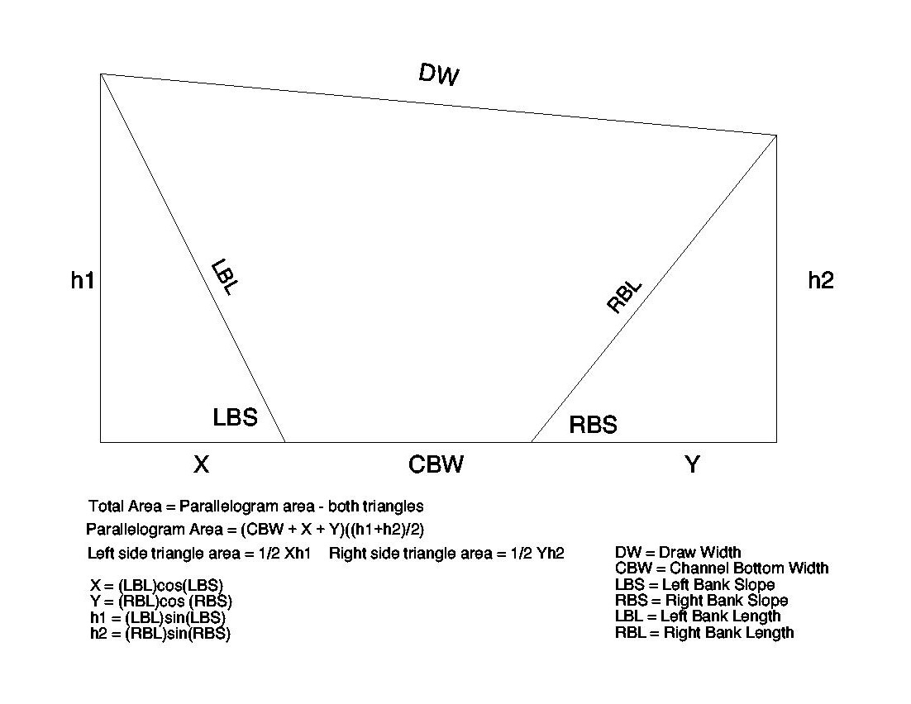
Figure 1.

This method allows for roads that had a significant gradient going through the crossing and yet keeps the measurements simple. Right and left should be measured facing downstream. If you make a mistake, you don’t have to redo the crossing because right and left are arbitrary as long as consistency is maintained throughout the cross-section (i.e., Left Bank Slope and Left Bank Length refer to the same bank).

Channel Bottom Width refers to the excavated channel. This may be different from the existing channel bottom width if significant adjustment/incision has occurred. In such cases, the observer should try as closely as possible to measure where the channel bottom was at the end of the project, before the adjustment occurred.

Total volume for the crossing is calculated by scaling the cross-sectional areas by the appropriate distance along the channel (see Figure 2). Cross-sectional area is assumed to be zero at the upstream and downstream end of the crossing.

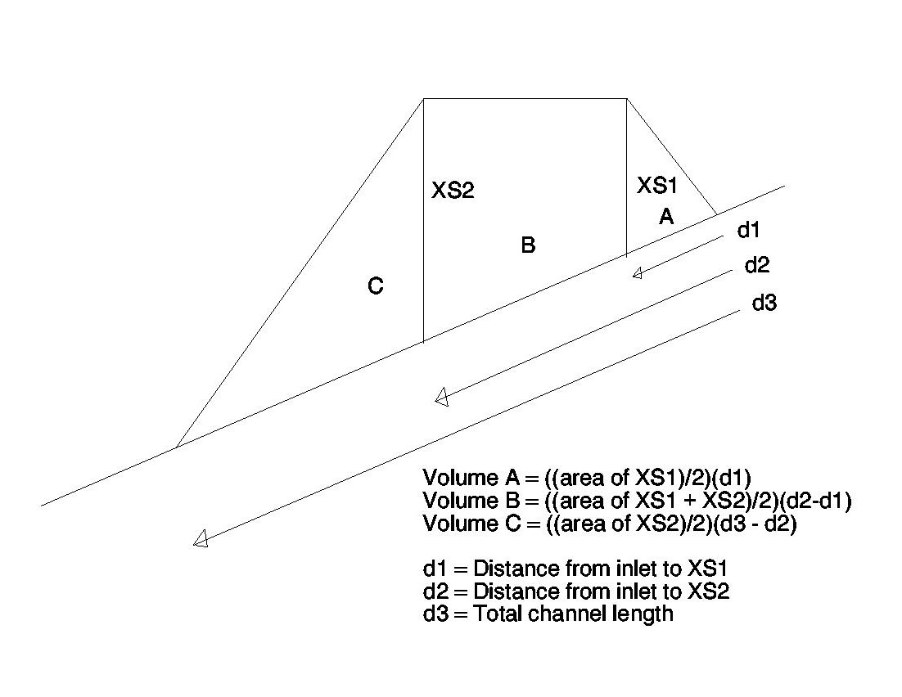
Figure 2.

Most crossings should be adequately measured with two cross-sections. There may be circumstances where a third cross-section is appropriate, and this model easily accommodates multiple cross-sections. In addition, in some cases only one cross-section is needed. This generally occurs where a cross-drain or very small crossing has been excavated. In this case, the profile is viewed as a rectangle with sides equal to the cross-section and bottom equal to the total channel bottom length.

Where the cross-sections are placed has a major influence on volume calculation. Cross-sections should be parallel to each other and perpendicular to the stream channel. If the stream channel is curved, the longitudinal profile should still be a straight line and the cross-sections should still be perpendicular to it. Use a compass to make sure everything is properly aligned.

Location of the upstream cross-section is usually straightforward. Place the upstream cross-section where the inboard edge of the old road meets the excavated crossing. The downstream cross-section, however, can be tricky if the road had significant curvature through the draw. In such cases the shoulder may be laid back and it may be difficult to find the old roadbed. Downstream cross-sections should generally be placed at the widest point of the excavation, with full knowledge of how the model necks down from that cross-section to zero at the bottom. Where significant road curvature exists, this model will somewhat over-estimate the volume of the crossing.

Measuring erosional features

For data collection purposes, all erosional features will be recorded using average width, average length and average depth. If this seems inappropriate, given the shape of the feature, other methods can be employed as long as the methodology is clear and the resultant volume is clearly obtainable. For instance, eroded channel width is often variable, with one section of channel considerably wider than another. In such cases, the two sections of channel could be measured separately and then added together.

When measuring features, be careful not to measure only the extremes. Remember that each width and depth applies to a certain length. It is OK to add these segments up. Alternately, you can measure the width and depth at intervals (e.g., one pace) and take a mathematical average. Don’t just take an average of the “bad” spots.

Type of feature (e.g., slump, gully, debris slide, etc.) should be noted and pictures taken. Use the following abbreviations: SWL = Swale; SPR = Spring; DTC = Ditch; OVR = Oversteepened Bank; WDT = Inadequate Width; UPS = Upslope Origination; PRE = Preexisting Slide Enlarged. If possible, the cause of the erosion should be investigated and discussed. All erosional features except channel erosion should include the percent of eroded volume that delivered to the stream network (channel erosion is assumed to be 100% delivery).

In most cases, the excavated channel will be U-shaped, and any channel incision will be a smaller U-shaped feature in the bottom. In some cases, however, it is clear that the channel has not down-cut, but has widened. In this case, measure the existing (enlarged) channel, and check the box to subtract the pipe volume. This will ensure that the void created when they removed the culvert is not counted as eroded volume.

Photos

Take a lot of photos. Take at least one photo of each crossing. Take photos of any unusual features and all erosional features. Due to the large number of photos that will be generated, and due to the similarity of the subject matter, keeping track of which photos belong to which sites will be imperative. For digital cameras, we recommend using the date-time stamp to identify photos. For analog cameras, record the roll and frame numbers and make sure these numbers follow the film through the processing and filing phase. It is a good idea to write the site name/number on the back of analog photos as soon as they are developed. Relabel digital photos with the road number, crossing number and photo number (e.g., 7N11_3_2)

GPS

To aid in drainage area calculations, we would like to have the GPS coordinates of each crossing. Record the GPS filename on the datasheet. Record the site number into the GPS unit. Because it is notoriously difficult to get satellite coverage at stream crossings, we have set a cut off of 15 minutes for getting coordinates. That is, if you haven’t got your satellites in 15 minutes, forget about it and move on.

Filling out the data form

Please take good field notes. Please write legibly and clearly. You will notice large amounts of the form have been given over for comments. This is no accident. You are encouraged to discuss any and every aspect of the project, particularly things that don’t fit nicely in the boxes. Use this area to discuss features and processes you observe. Also use this space to discuss any deviations from protocol or other information that will make it clear to someone reading the forms how measurements were taken or how they should be interpreted. In most cases, we will not return to the site. Good field notes and photos will be all we have. Take the time to make your notes clear and complete. Paper is cheap. Use as much as you need.

Number the stream crossings and cross-drains sequentially from the beginning of the project. If stationing exists, record that at each site as well.

In addition to measuring the excavated and eroded volumes, field crews should answer the following questions:

- Were road fills located in swales excavated and recontoured or were they left in place? Are the swales (excavated or not excavated) eroding?

• If stream channel adjustment is evident, has it stabilized or is it susceptible to chronic future adjustment and sedimentation? Why? Explain. Do this for every erosional feature.

• For all erosional features, is there evidence indicating poor contract design or implementation? Cite your field evidence and list your assumptions. How could this problem be corrected in future projects?

• Was the roadbed between crossings ripped or sub-soiled? If so, are there associated erosional problems? Does the ripping/sub-soiling appear to have facilitated revegetation and colonization of native vegetation?

Finally, if the contract is available, when finished with a road, fill out the BMP monitoring form (E-10) for that road. Also record the engineer’s estimate of the amount of fill removed at crossings, if available.

