R-5 BMPEP

On-Site Evaluation E10

Road Decommissioning

(Reference BMP 2.26) revised 10/2001

Header Information Unique To This Form
Project: Note if project had or did not have stream crossings.
Project Status: Enter year road decommissioned.
Crossing: Identify whether a stream crossing is within evaluation site.

Developing The Sample Pool And Selecting The Evaluation Sites
First, make a list of all system (classified), non-system (unclassified) and temporary roads decommissioned or obliterated on the Forest. Randomly select from the sample pool the number of decommissioned road evaluations assigned to the Forest for the year.

Timing Of The Evaluation
The E10 BMP Evaluation is complex and requires a high degree of coordination and two trips to the sample site. Implementation is evaluated any time after the decommissioning treatments have been completed. Effectiveness is evaluated shortly after the project has been completed and after the project has gone through at least two winter seasons.

Conducting The Implementation Evaluation

For All Decommissioning Projects
Implementation of road decommissioning involves a combination of field survey and review of environmental documents, plans and contracts. These criteria are rated for all projects; an additional four criteria are rated for projects with stream crossings.
Review the contract and/or decommissioning plan and planning documents (including NEPA, biological assessments, etc.) to determine if water quality issues identified by the ID team were incorporated into and addressed by the design and contract or plan.
- Did the ID Team consider the potential and actual effects of roads on water quality? Did plans address water quality? Were pre-project surveys of springs, areas prone to landsliding, and extent of fills conducted?
- Did the final design incorporate mitigations included in NEPA, Biological Opinions, Biological Assessment, or other controlling documents?

Conduct a field review by walking the entire length of the project. Compare environmental documents, contract information, and/or site designs against on the ground results to determine if the project/contract requirements were met for:
- Treating the road surface?
- Disposal Areas?
- Reshaping or stabilization of the road prism?
- Ground cover re-vegetating and/or other erosion control in areas disturbed by treatments?
- Physical closure of the road to unintended vehicle use?
For projects with stream crossing(s), compare the plan requirements against ground results to determine:
- Was fill beneath culverts removed as per the specifications?
- Does the resulting excavated channel closely match the natural channel (both upstream and downstream) in width, grade, and alignment?
- If grade control or energy dissipating structures were called for, were they installed as specified?
- Were the sideslopes at the crossing excavations configured as specified?
If problems occurred in implementation, identify which phase or phases the problems can be attributed to; and describe the deficiencies and possible corrective actions in narrative form (this is very important, please do not skip or skimp on this part).

Conducting The Effectiveness Evaluation

For All Decommissioning Projects
Locating The Sample Site: Effectiveness is assessed by walking the entire length of the decommissioned road. Along this transect, observations are made at a minimum of 3 crossing sites at the largest channels are tallied. Evidence of mass failures is tallied per 1500 feet of road. Determine the length of transect by pacing. Also tally the length of road with rills or gullies greater than 20 feet in length and 2 inches deep. Note also the condition of areas where excavated material has been stored.

Sampling Protocols
After the entire transect is observed, rate the following effectiveness criteria:

Road surface rilling:
Divide the paced length of the transect with rills > 2” deep and 20’ in length by the total paced transect length. Rills/gullies running longitudinally are tallied by their full length; rills/gullies running transverse to the road surface are tallied by the longitudinal distance of road which they occur. Compare this result with the categories on the form.

Disposal area rilling:
Excavated material removed from channels or from pulled fillslopes, etc. is placed in designated disposal areas. Based on observations of these areas made while walking the transect, rate the amount of rilling and delivery to channel observed. Exclude areas where the road surface serves as the disposal site so as not to double count rilling accounted for under “road surface rilling”. “Numerous rills” are defined as greater than 1 rill per lineal 5 feet.

Road prism fillslope rilling:
Based on observations made while walking the transect, rate the amount of rilling occurring on re-contoured or pulled fillslopes within the road prism. “Numerous rills” are defined as greater than 1 rill per lineal 5 feet. Note: fillslopes at excavated channel crossings are evaluated separately below.

Slope failure:
Walk the road and observe all incidences of mass-wasting slope failures. Tally and make a volume estimate for those failures.

Traffic control:
Whatever method of traffic exclusion or control was used, evaluate its effectiveness based on whether evidence of unintended vehicular use is present.

For roads where stream crossings are present:
A minimum of three (3) excavated stream crossings encountered along the road are evaluated and tallied; the summary rating for each of the effectiveness indicators (existing channel adjustment, future channel adjustment, excavated sidslope rilling, and slope failure) is derived from the numerical average of sites evaluated. Assign a numeric score for the indicator condition described on the evalution form. For example, under existing channel adjustment indicator: 1 = “little downcutting…”, 2 = “moderate downcutting…”, and 3 = “extensive downcutting…”. For each indicator, add the combined scores and divide by the number of sites (crossings) evaluated to obtain a numeric average. Rounding to the nearest whole number should indicate the appropriate condition box to check for each parameter.

Adjustments of channel:
Rate the adjustment of the channel. This criterion is based on comparison of the degree of existing and anticipated channel adjustment. Evaluation of existing channel adjustment is based upon observations of lateral scour, downcutting, channel stability from two site visits; the first shortly following project completion and second following two or more winter seasons. To facilitate assessment of post winter channel adjustment, photo points on stream crossings must be established prior to the first winter in order to facilitate a baseline for evaluating post winter channel adjustment. In addition to photo point monitoring, the extent of channel adjustment should also be compared to an upstream area, which is presumed to represent the channel’s natural geometry, and forms a basis of what can be considered reasonable and unavoidable adjustment. Rate and tally existing adjustment of the channel at excavated stream crossings by comparing areas of the channel eroded since the excavation was completed and after two or more winters (see figure E10-1). Rate and tally future adjustment of the channel at excavated stream crossings by evaluating the stability and recovery of project associated adjustments along the excavated channel. In other words, evaluate whether or not the excavated stream channel stable or is likely to continue to adjust for the foreseeable future and deliver sediment through sideslope failures or continued downcutting and gullying. When evaluating existing and future channel adjustments, a clear understanding of the range of acceptable and unacceptable post excavation channel conditions must be defined.

An excavated stream crossing that is stable can be defined as having little post project channel adjustment and no foreseeable future channel adjustment. The stream channel is at natural grade, channel width mimics the native channel, and channel sideslopes are not oversteepened or prone to future failure as a result of project design. Stream crossings in this category would be rated as meeting project intent with minimal sediment delivery.

An excavated stream crossing that has experienced moderate downcutting and lateral adjustment can be defined as undergoing more channel adjustment than was anticipated in the project design. However, the channel is still stable and will not continue to adjust and deliver significant sediment into the foreseeable future. For example, the stream channel may have downcut more than anticipated, or a small slump occurred on a channel sideslope where insufficient channel width was left. Despite the unanticipated adjustments, no significant future sediment delivery is likely, the channel is stable, and project intent was essentially met.

An excavated stream crossing that has experienced extensive downcutting and lateral adjustment can be defined as a channel that is not stable and will continue to deliver significant sediment into the foreseeable future (e.g. next winter or moderate storm event). For example, the channel bottom will continue to downcut and widen, which will undermine sideslopes and cause slope failures. Chronic sedimentation is anticipated to continue and the project intent was largely not met.
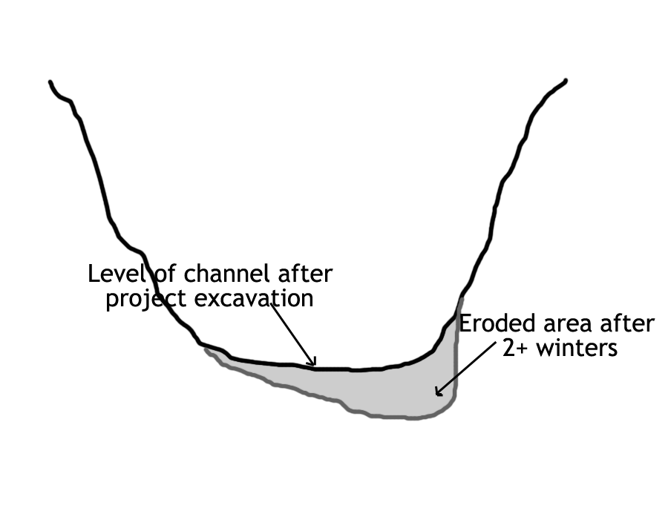

Figure E10-1. Excavated channel, after project and after channel adjustment.

Excavated sideslope rilling:
Based on observations of selected stream channel crossings evaluated within the project area, tally and rate the amount of rilling occurring on newly excavated or pulled sideslopes at channel crossings.

Slope failure:
Walk the road and observe all incidences of mass-wasting slope failures. Tally and make a volume estimate for those failures.

Note on Adjustments of Excavated Stream Crossing Fills in Different Geomorphic Settings:
Sideslopes and newly excavated channels are expected to adjust for several years following removal of a fill because the site conditions that existed before the crossing was built cannot be duplicated. The type and amount of channel and sideslope adjustment will vary substantially for different sizes of fills and different geomorphic settings.
Projects should be designed, executed and evaluated for effectiveness with this inherent landscape variation in mind. Although it cannot be easily quantified, the degree of adjustment that can be reasonably expected should vary directly with the size of the disturbed site and the steepness or relief of the surrounding topography, and inversely with the relative competence of the underlying materials; these factors are related to the geomorphic setting of a site. For example, minimal downcutting or slope instability would be expected within competent bedrock, whereas substantial downcutting and some mass movement should be expected within a large landslide deposit of fine-textured colluvium. Experienced earth scientists can make reasonably consistent estimates of expected adjustments based on observable site characteristics, and can also help adjust the design to mitigate for most adverse characteristics (e.g., special channel armoring or slope protection).

The size and geometry of the excavated fill also affects the engineering feasibility of achieving an end product that is likely to experience minimum adjustments. Professional judgment typically will be applied during design and execution to determine a rational tradeoff between total site disturbance and residual sideslope steepness or percent of the fill that can realistically be removed. Usually, most of the fill that cannot be removed will contribute to the site adjustment.

